Collagen Growth Exploration

# Vector Trails along Curves

Fiber growth in this manner relies on vector fields through which a point will be propagated. At each point in the volume, a vector is stored that contains the direction a particle will be pushed each iteration. By storing the location of the particle at each discreet moment in this iteration, a trail is left behind that can be traced to create a strand-like structure that has a strong visual resemblance to collagen fibers

## 

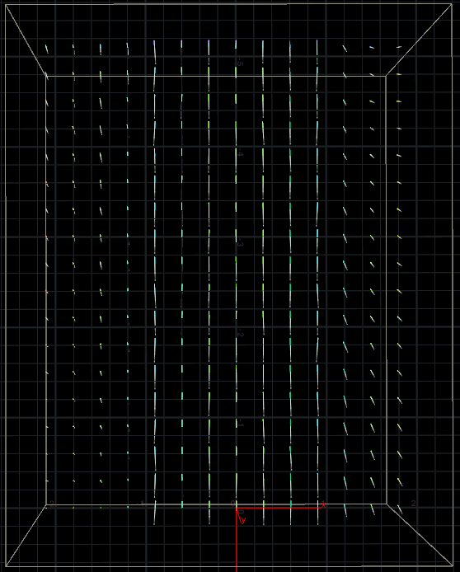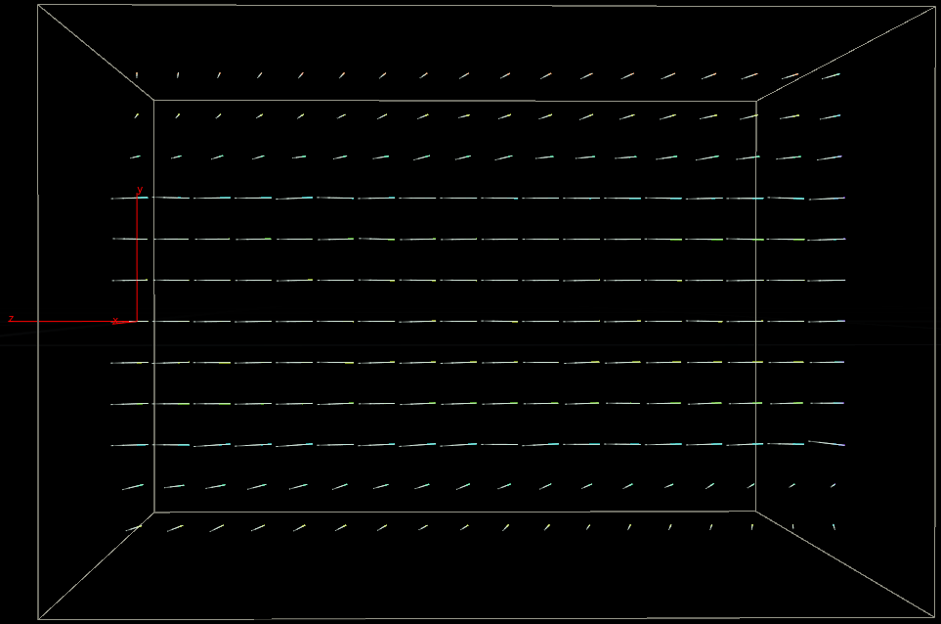

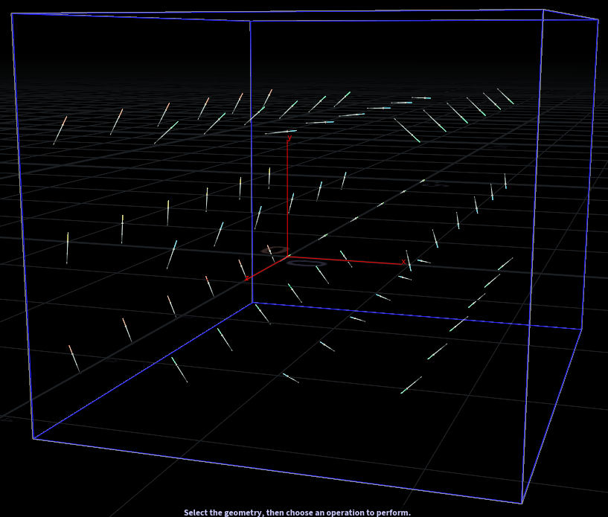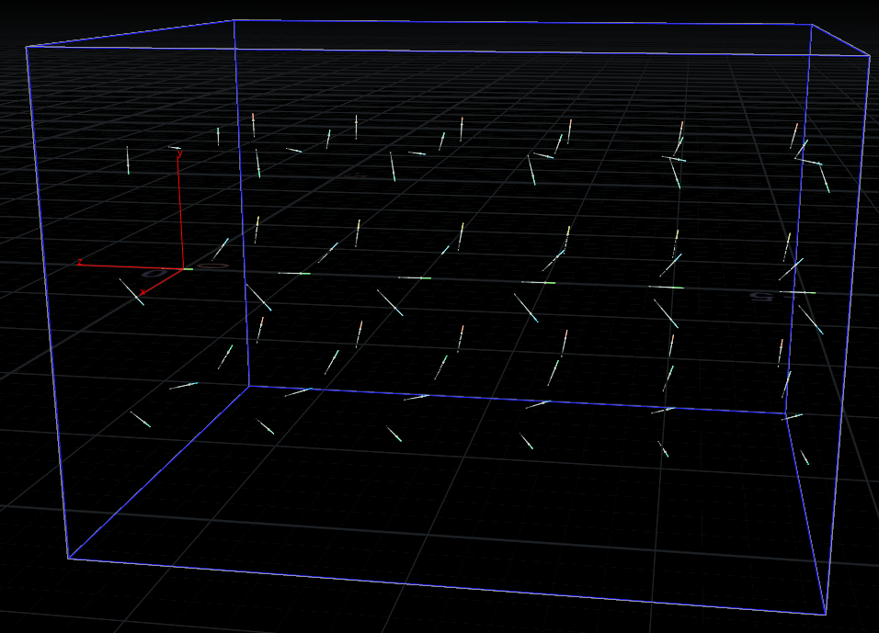

These images illustrate the vector field used to grow the above images

These vector fields illustrate this concept, at each discreet point inside the volume, there is a direction stored, indicated by the short lines, that the particle will travel along until entering a new voxel, and beginning to travel in that direction. Using this method, we can extrude a line through a volume that has been processed to contain the growth vectors for collagen at any discreet point within the tissue.

This can be thought of as a spark drifting through the wind. If you were to take a long exposure camera shot of a spark drifting through the wind, the resulting photograph would have one long line showing you what path the breeze is following, the particle extrusion here follows the same principle.

The advantage of using this method, is that it allows for the use of vector-field data collected in experiments to be input directly into the 3D software, and used to create physically accurate sections of tissue procedurally, with minimal user input.

## Along the Z-Axis

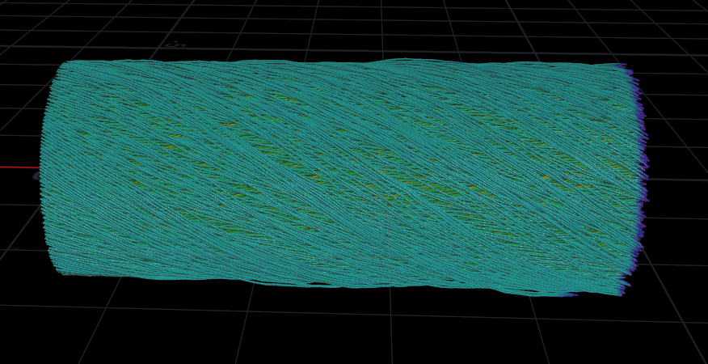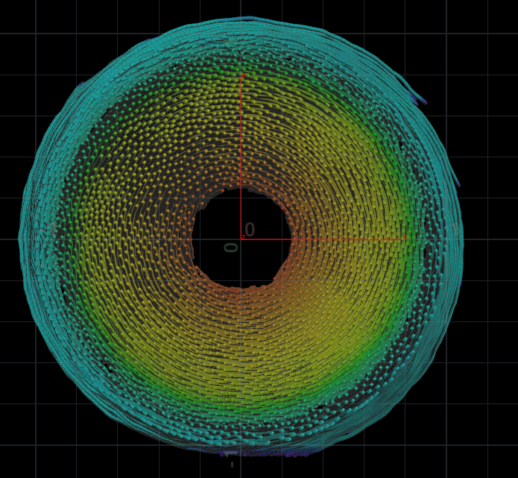

Collagen Fibers grown along the length of the Z-Axis in Houdini

The simplest demonstration of this was creating collagen that grew along the Z-Axis inside of Houdini. I was able to use a small amount of input data (a direction of travel, in this case –z) and the cross-product of the strands vector towards the curve, and its vector of travel, this gave me the rotational vector at any point it needed to be calculated from.

In this demonstration, I was able to adjust the angle at which the fibers twisted around the length of the tube based on a weight value I applied to the rotational direction vector that was used to populate the volume.

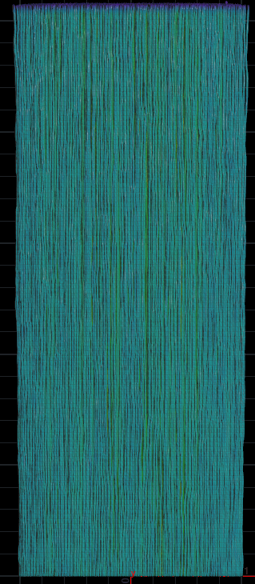 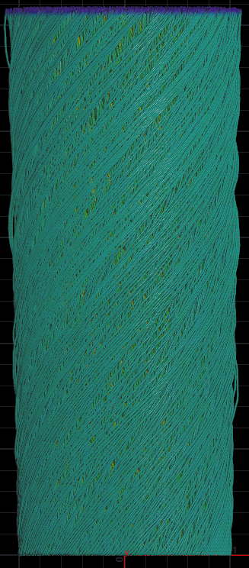 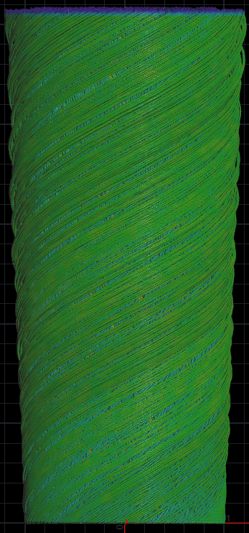 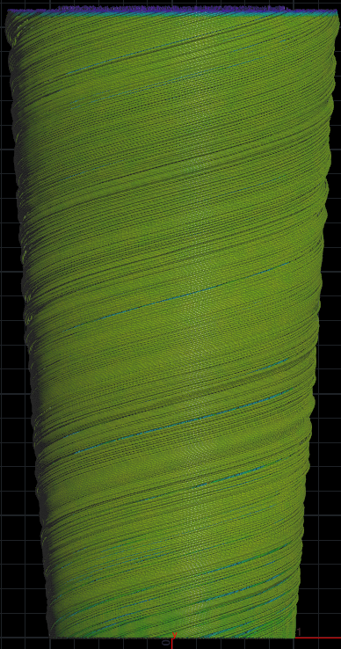

Weight: 0 Weight: 1 Weight: 2 Weight: 4

The weighting to fiber orientation angle allows me to direct how steep the angle of the strands is as well as allows me to direct how tightly interwoven the strands are.

## Along a pre-drawn Path

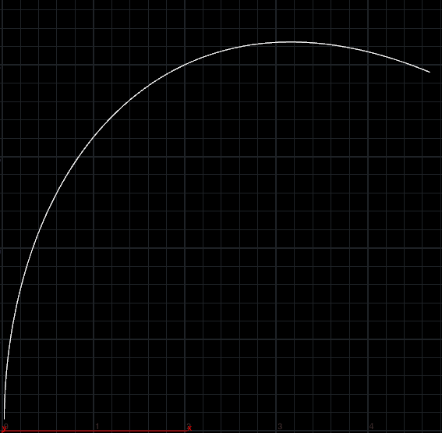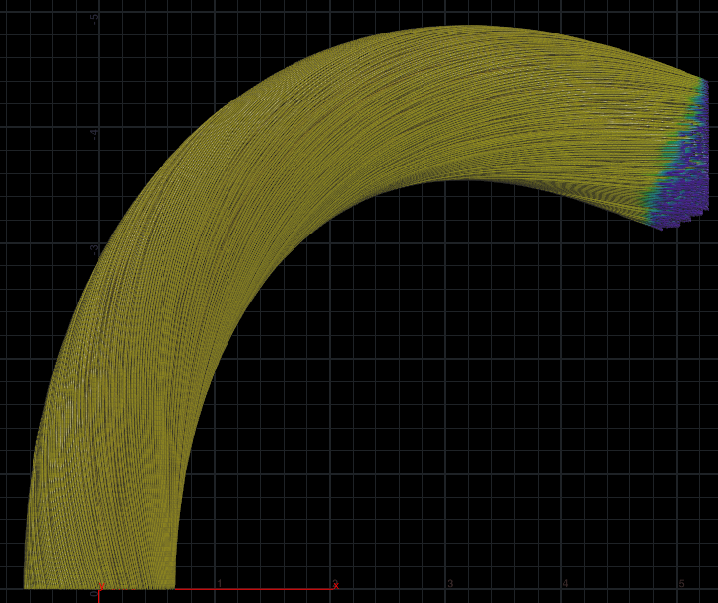

Collagen Fibers grown along a hand placed spline in Houdini

In order to create more complex structures, I created a spline that I was able to drive collagen growth along as well. Like the original test, this collagen is able to traverse the path, and be braided around the curves axis, at a user specified level, as shown below.

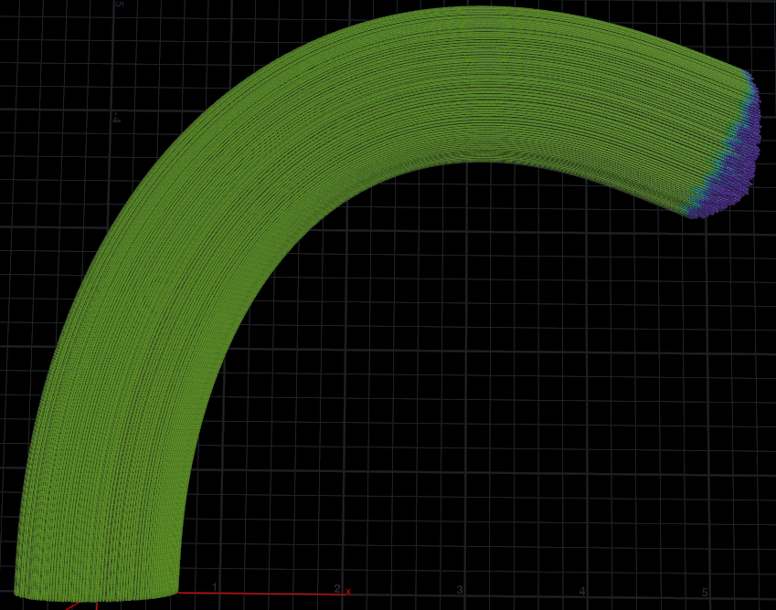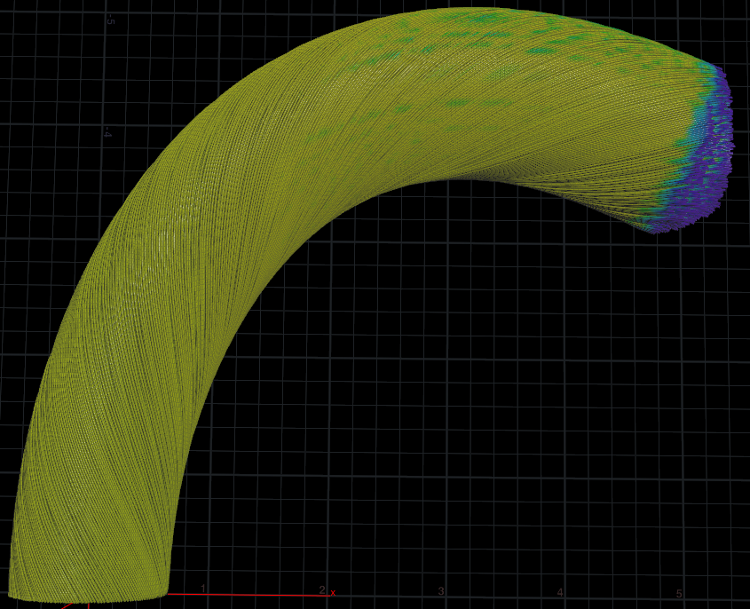

Weight: 0 Weight: 1

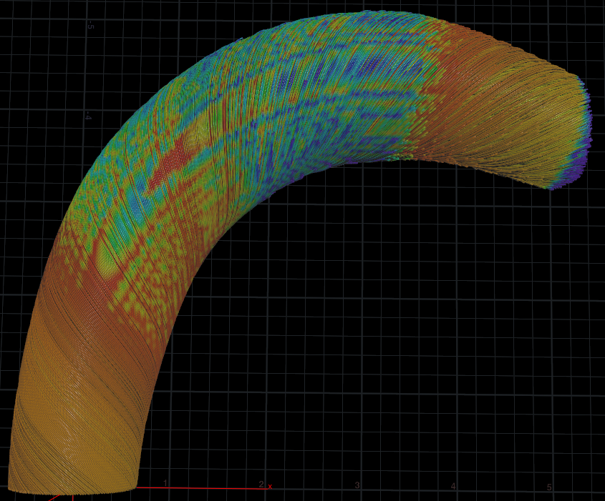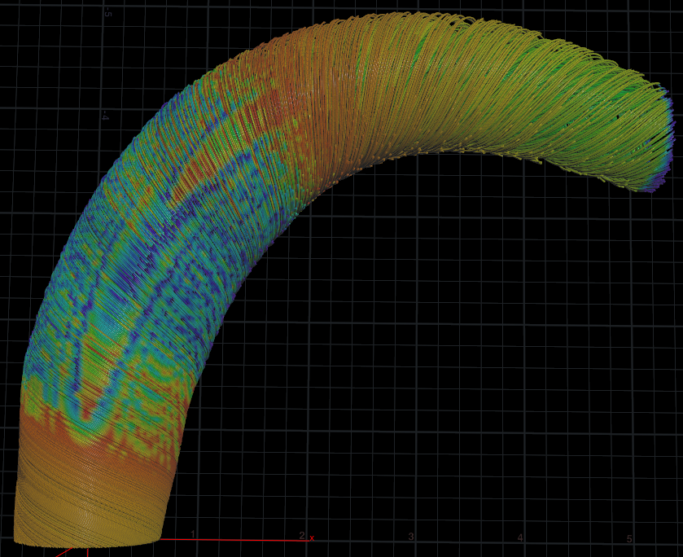

Weight: 2 Weight: 4